***Parseh language Academy***

***Answer Key Final Test Touch Stone 1.1***

**A**

1. b 2. b 3. c 4.a

**B**

1.***A*** Is the computer new?

***B*** No, it’s not.

2.***A*** Are your co-workers nice?

***B*** Yes, they are.

3.***A*** Am I late for class?

***B*** No, you’re not.

**C**

1.***A*** I’m

***B*** their

2.***A*** We’re

***B*** I’m

3.***A*** your

***B*** He’s

**D**

1. c 2. B 3. E 4. A

**E**

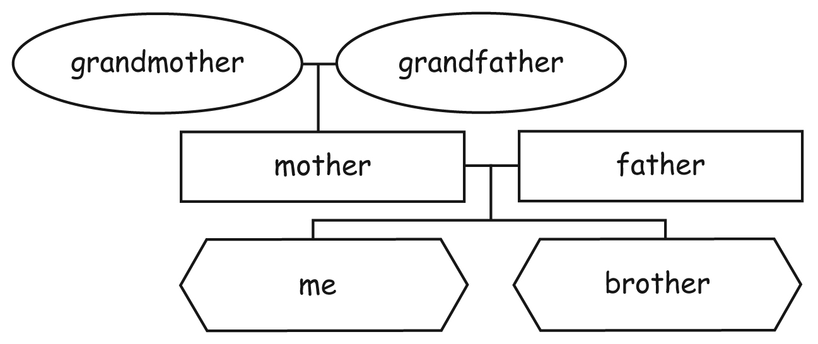

**F**

1. They’re not friendly.

2. He’s not at home.

3. It’s not very good.

**G**

1. 2 Really? What about your boss?

1 My new co-workers are nice.

3 She’s great. And she’s not very strict.

2. 3 My favorite player is Sergio Agüero.

1 I’m a soccer fan.

2 Soccer? Really? Who’s your favorite player?

3. 1 Where are you from?

3 Miami? Really? I’m from Miami, too.

2 I’m from Miami.

**H**

1.***A*** Where’s

***B*** under

2.***A*** Where are

***B*** in

3.***A*** Where’s

***B*** next to

4.***A*** Where’s

***B*** on

**I**

1. What’s the word for this

2. Can you repeat that

3. Can I borrow your

4. How do you spell

**J**

1. markers

2. window

3. wastebaskets

4. door

5. board

6. table

**K**

1.a  2. c  3.b  4. c

**Audio script (Track 4)**

*John* This is a great photo, Dana. Who is she? Your sister?

*Dana* No, she . . .

*John* Oh, does she work with you?

*Dana* No, she’s a friend of mine. Her name’s Emma.

*John* Emma? That’s a nice name. Is she from London?

*Dana* No. She’s from Miami originally.

*John* Miami?

*Dana* Yeah, but she’s here in San Diego now.

*John* Really? Is she a student?

*Dana* No, she’s a singer. Her voice is amazing.

*John* Wow. . . . And who’s this?

*Dana* This is my sister. Her name’s Laura.

*John* Oh, your sister? How old is she?

*Dana* She’s twenty-one. No, no, she’s twenty-   
um, two.

*John* Twenty?

*Dana* No, twenty-two.

*John* So, is she like you?

*Dana* Laura? No, she’s very shy.

*John* Really? That’s amazing. You’re so outgoing.

*Dana* Yeah, we’re really different. ..